English Martyrs
ENGLISH MARTYRS PARISH
ALVASTON & CHELLASTON

Hollis St, Alvaston

DE24 8QU

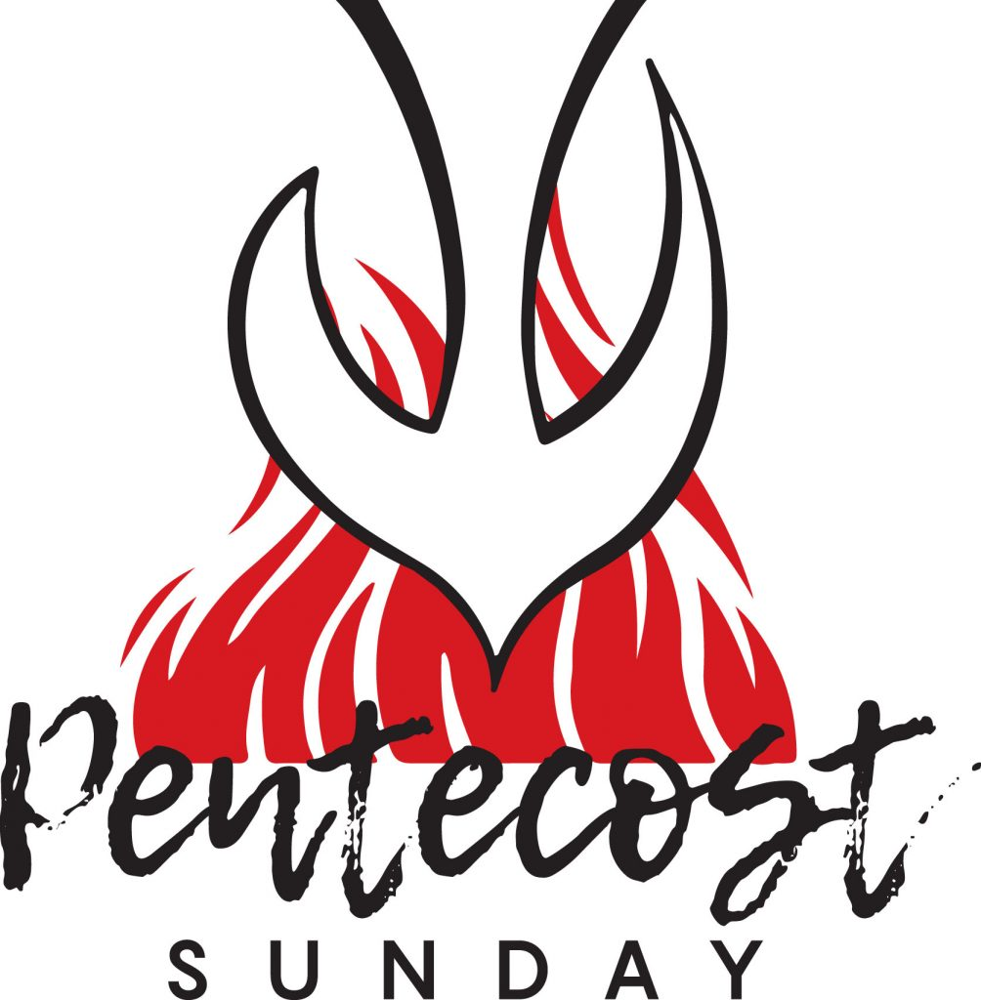
Pentecost (A)
24 May 2026
Psalm Response: Send forth your spirit, O Lord,
and renew the face of the earth

Sun: 9.00am Mass Jordan Fam. RIP
11.00am Mass Jackie Blaney 80 B’day
2.00pm First Holy Communion Mass FHC Candidates

Mon: Mary, Mother of the Church
12 noon Mass Dennis Sherwin & Fam RIP

Wed: St Augustine of Canterbury (Feast)
12 noon Mass Pat Murray RIP
Thurs: Jesus Christ, Eternal High Priest (A) (Feast of the Lord)
12 noon Mass Norman Annable RIP

Fri: NO MASS

The Most Holy Trinity (A)
Sun: 9.00am Mass Liz & Terry Spencer Int
11.00am Mass Maime & David Westwood RIP

D

Money Matters:

Offertory: £495.78
Ascension: £282.17

For those who regularly contribute to the Church via the Envelope Scheme,
another option would be to set up a Monthly or Weekly Direct Debit or Standing Order. If you contribute by any of these methods and you pay Income Tax, please consider Gift Aiding your contributions to the Parish, this is worth an extra 20% to the Parish without costing you any more than your Gift to the Parish.
Lloyds Bank: sort code 30-92-59;
Account number 01620555 – English Martyrs, Derby RCP.
(Gift Aid forms available at the back of Church)

Payments to the parish by cheque should be made payable to:
English Martyrs Derby RCP

Sanctuary Lamp:

Prayers for the Sick: Please always keep in your prayers the sick and housebound especially Simon Thompson, Christine Dreuitt, Giovanni Busato, Ian Robinson, Bart Makowski, Joe Migallo, Liam Blaney, Christopher Turner, Tracey Reeve, Terry & Liz Spencer, Mick & Frances Connolly, Maria Latwiel, Anne Smith, Margaret Meagher, James Wilson, Libby Dodes, Gregory Makowski, Brian Campbell, Mary Storer, Peggy Whelan, Ann Curley, Joyce Bowker and Veronica Wood.

Father M Brentnall VF [Parish Priest] Contact: 01332 574474
Email: englishmartyrsderby@outlook.com www.englishmartyrsparish.org.uk
Newsletter Admin: Anne Walsh – annew505@gmail.com 07980 568261 Hall Enquiries: Rita Merrison

St Philip (First century) was from Bethsaida and, after being called by the Lord, introduced St Bartholomew to Him. He may have been crucified at Hierapolis in Phrygia, where he had preached the Gospel.
St James ‘the l

Second Collection next week, Sunday, 31 May for Catholic Communications (Transferred from last Sunday)

Lend your voice to the Choir
We are looking for new members to help lead the congregation in singing at the 11am Mass on Sundays.
Joining the Choir is a wonderful way to make new friends, deepen your faith and serve our parish community.
In the coming weeks we will be aiming to practice the hymns for the Mass about 15/20 minutes before the commencement of Mass.
Please come and join us if you enjoy singing

If you’re interested, please come to English Martyrs early to practice regularly and if you are unable to go upstairs to the choir area please stay downstairs near the organ as practices will take place there.

Confirmation: Application forms for Confirmation are available at the back of Church. Classes will begin on Saturday, 13 June at 10.30-11.30am at English Martyrs Church. All children under 16 must be accompanied by an adult. Classes will continue on the following Saturdays until Confirmation which will take place at English Martyrs’ Church on Sunday, 12 July at 11.00am Mass.

Food Donations: Thank you for your continued donations to the Food Appeal. The box will remain at the back of Church for your donations when you can.

Please Pray for the repose of the soul of those who have died. May they rest in peace.

Blessed Virgin Mary, Mother of the Church (Memorial) – 25 May:
It is fitting that, the day after Pentecost, the birthday of the Church, Mary is honoured as Mother of the Church. Though only introduced by Pope Francis in 2018, this celebration is noted in the writings of the early Church Fathers. Mary is not only Mother of God but also mother of every Christian, entrusted to her care through the person of St John at the foot of the Cross. In the words of St Paul VI: ‘the Blessed Mother of God, the New Eve, Mother of the Church, continues in heaven her maternal role with regard to Christ’s members, co-operating with the birth and growth of divine life in the souls of the redeemed.’

St Philip Neri, Priest (Memorial) – 26 May:
St Philip Neri (1515-1595) was born in Florence but spent most of his life in Rome and is known as the city’s ‘apostle’. He had a mystical experience in the catacombs in 1644, when he ‘felt himself divinely filled with the power of the Spirit’, causing his heart to dilate. Ordained in 1551, he founded the Congregation of the Oratory. He was noted for his constant joy and the love he showed those who came to him for counsel or confession.

St Augustine of Canterbury (Feast) – 27 May:
St Augustine of Canterbury (+ c.604) was a monk at St Andrew’s on the Celian Hill in Rome. He was sent by Pope St Gregory the Great to convert the English people. Landing in Thanet, Kent in 597, he baptized King Ethelbert, and many of his subjects. He founded a monastery and a cathedral at Canterbury, and established sees at Rochester and London.

