English Martyrs
ENGLISH MARTYRS PARISH
ALVASTON & CHELLASTON

Hollis St, Alvaston

DE24 8QU

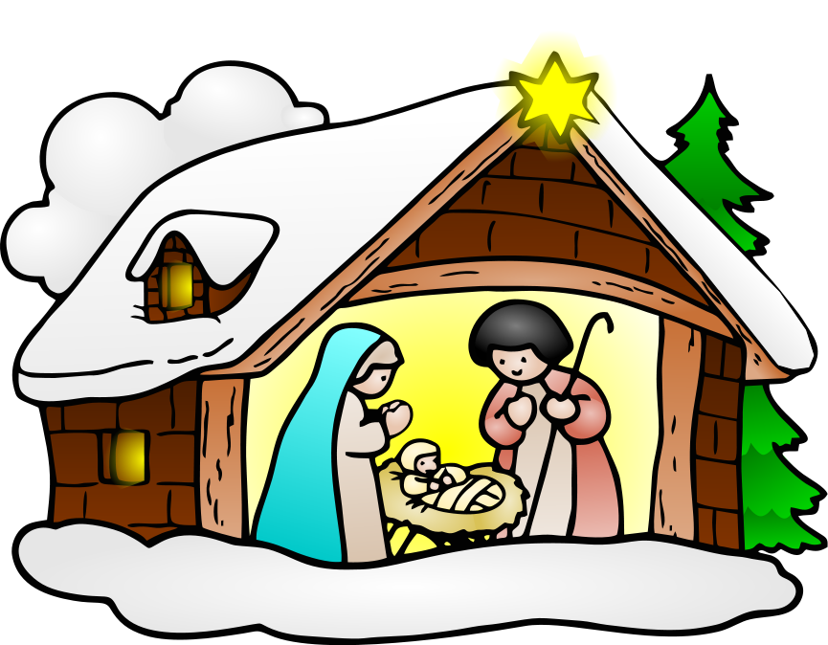
Third Sunday of the Year - A
25 January 2026
Psalm Response: The Lord is my light and my salvation

Sun: 9.00am Mass Fr Slavik RIP
11.00am Mass Winnie & Joe Hartley RIP

Mon: Ss Timothy & Titus
12 noon Mass Chloe Small Int.

Wed: St Thomas Aquinas
12 noon Mass Jim Doyle RIP

Fri: NO MASS

4th Sunday of the Year A
Sun: 9.00am Mass William Johnson RIP
11.00am Mass Joe Fernando Int.

D

Money Matters:

Offertory: £604.48

For those who regularly contribute to the Church via the Envelope Scheme,
another option would be to set up a Monthly or Weekly Direct Debit or Standing Order. If you contribute by any of these methods and you pay Income Tax, please consider Gift Aiding your contributions to the Parish, this is worth an extra 20% to the Parish without costing you any more than your Gift to the Parish.
Lloyds Bank: sort code 30-92-59;
Account number 01620555 – English Martyrs, Derby RCP.
(Gift Aid forms available at the back of Church)

Payments to the parish by cheque should be made payable to:
English Martyrs Derby RCP

Sanctuary Lamp:

Prayers for the Sick: Please always keep in your prayers the sick and housebound especially Simon Thompson, Christine Dreuitt, Terry Bullock, Giovanni Busato, Ian Robinson, Bart Makowski, Joe Migallo, Liam Blaney, Christopher Turner, Tracey Reeve, Liz Simmons, Terry & Liz Spencer, Mick & Frances Connolly, Maria Latwiel, Anne Smith, Margaret Meagher, James Wilson, Libby Dodes, Gregory Makowski, Brian Campbell, Mary Storer and Peggy Whelan.

Please pray for the repose of the soul of Eamonn Murray. May he rest in peace. Please remember his family in your prayers.
Funeral: Reception 7.00 Mon 2 Feb at St Joseph’s
Funeral 10.30 Tues 3 Feb at St Joseph’s

Father M Brentnall VF [Parish Priest] Contact: 01332 574474
Email: englishmartyrsderby@outlook.com www.englishmartyrsparish.org.uk
Newsletter Admin: Anne Walsh – annew505@gmail.com 07980 568261 Hall Enquiries: Rita Merrison

St Philip (First century) was from Bethsaida and, after being called by the Lord, introduced St Bartholomew to Him. He may have been crucified at Hierapolis in Phrygia, where he had preached the Gospel.
St James ‘the l

Churches Together in Chellaston: Ecumenical Prayer and Praise Service at 3.00pm today Sunday, 25 January at St Peter’s Church, Chellaston followed by afternoon tea. All welcome.

Second Collections: There will be a second collection next Sunday,
1 February for the Diocesan Quota.
22 February for the SVP (For the poor and needy)

300 Club: The winners of the January draw are:
£100 1 Margaret Meagher
£50 158 Linda O’Donnell
£25 129 David Gabriel
£25 160 Fr Mark Brentnall
£25 153 Malcolm Caporn
£25 55 Mary Murray
Well done all

SVP: Following on from the Christmas Food collection, we have decided to leave the box at the back of Church for you to leave donations if and when you can. This will continue to support those in need in the Parish and also the Food Bank run by Alvaston Parish Church on Elvaston Lane.
Items the Food Bank would particularly like are: Tinned Meat, Coffee, Rice Pudding, Toddler nappies and Baby Wipes. Thank you.

Do you have a child ready to start School in September 2026: (Or move into Year 3) Do you have a friend or family member who does?
St John Fisher will be giving tours of the School to prospective parents every Monday at 10-11am and 1-2pm. No need to book – just turn up!

‘Christian love, either towards God or towards man, is an affair of the will
CS Lewis’

Ss Timothy & Titus, Bishops (Memorial) – 26 January:
Ss Timothy and Titus were both disciples of St Paul, who addressed to them three of his Epistles. St Timothy (+ 97) accompanied the Apostle on many of his journeys and eventually became bishop of Ephesus. According to tradition, he was beaten to death by a mob when he opposed the worship of Dionysus.
St Titus (+ c.96) seems to have served as the first bishop of Crete.

St Angela Merici, Virgin (Opt Mem) – 27 January:
St Angela Merici (1474-1540) was born near Verona, Italy, and devoted herself to the education of girls and the care of the sick. In 1516 she founded the Institute of St Ursula (Ursulines), the first teaching order for women approved by the Church.

St Thomas Aqiomas, Priest and Doctor of the Church (Memorial) – 28 January:
St Thomas Aquinas (c.1224-1274) was a Dominican friar who became one of the most important Christian philosophers and theologians. Known as the ‘Angelic Doctor’, he had an astonishing mastery of scholastic theology and a profound holiness of life. His greatest work, the Summa Theologica, is still widely used. Pope Leo XIII declared him patron of Catholic schools.

St John Bosco, Priest (Memorial) – 31 January:
St John Bosco (1815-1888) was born in Piedmont (Italy) and devoted his life to Catholic education. The ‘Apostle of Youth’ founded the Salesian Order, named in honour of St Francis de Sales, and with the help of St Mary Mazzarello, the Daughters of Mary Help of Christians.
Despite meeting much opposition, his aim was, above all, to educate through love.

